

**BY-LAWS**

**OF**

**THE METHVEN MASONIC LODGE No.51 N.Z.C.**

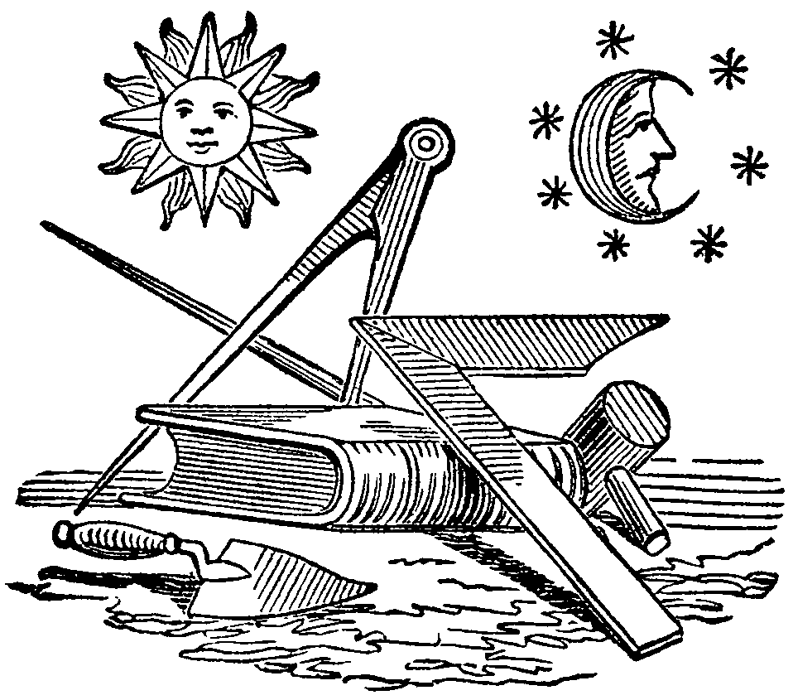

Under the GL Book of Constitution

2000